ECM Removal – for 2017-2019 Silverado/Sierra 6.6L Duramax L5P
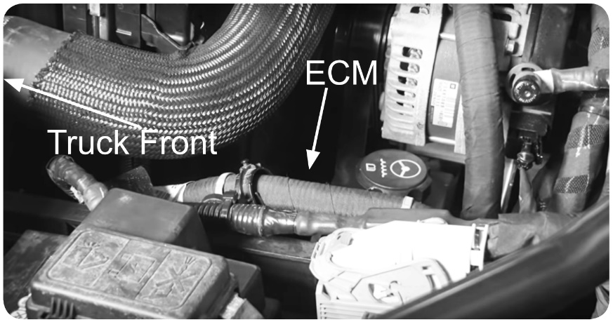
STEP 1 – Locate the vehicle’s ECM. It will be on the driver side of the engine bay, below the coolant hose, cradled in a plastic bracket.
STEP 2 – Remove the small blue connector (closest to the front) from the ECM by sliding back the retaining clip (1), holding in the tab (2) and carefully opening the clamp (3) until it disconnects.
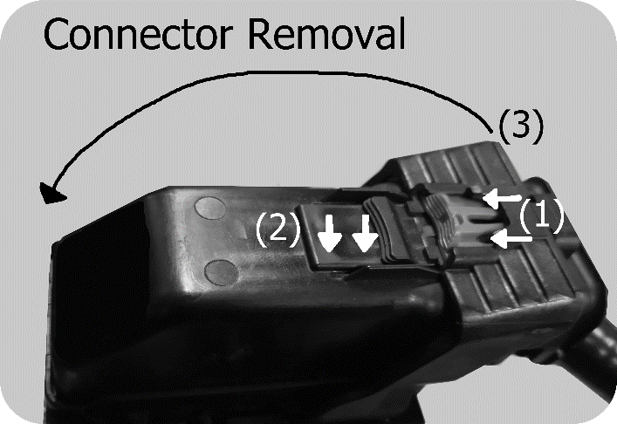
STEP 3 – Depending on truck year, remove the plastic push rivet (2017), or remove the 10mm bolt (2018-2019) holding the ECM to the bracket, located on the top front corner of the ECM.
NOTE: Keep the bolt to ensure the ECM is secured when reinstalled.
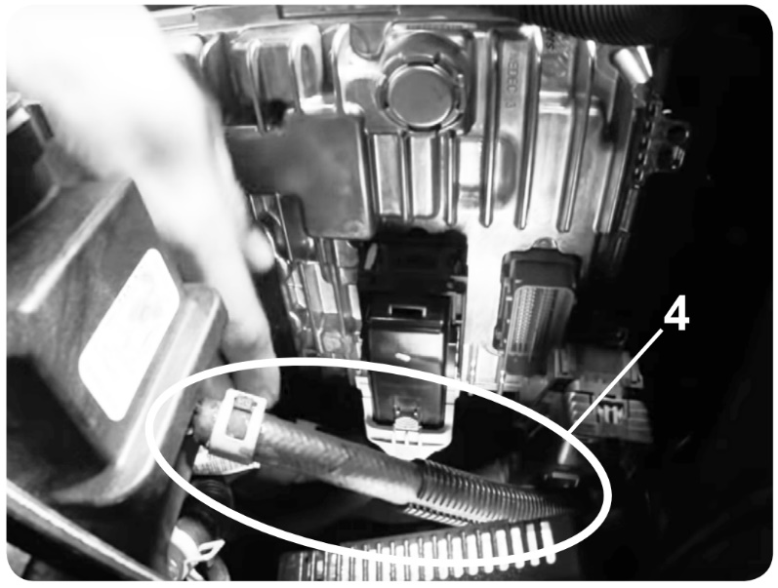
STEP 4 – Carefully remove the ECM from the bracket by sliding forward and upwards, then (for more room) lower the ECM until center connector is below the power steering hose. (4)
STEP 5 – Removal of the other two connectors is similar to the one already removed in Step 2. Disconnect the center, small black connector by sliding in the green clip (1), pressing in the tab (2), and then open the clamp (3), until it disconnects.
STEP 6 – Pull the ECM up and above the Engine Bay until there is room to disconnect the final large black connector. Simply slide and press in the green clip (1), press in the tab (2), and then carefully open the clamp (3) until it disconnects.

REINSTALLATION – Slide the ECM carefully under the upper coolant hose and near its mounting cradle. Do not seat it in the cradle yet. Ensure the ECM is oriented so the circular protrusion is on the top side, and the connector slots are vertical. Without seating the ECM in the cradle, slide the ECM towards the radiator to give clearance to plug in the long black connector, furthest from the truck front. Open the lever on the connector all the way, then press the connector onto the plug. Close the lever until it clicks, then slide in the green locking clip.
Lower the ECM down to give clearance for installing the center, short black connector. Reinstall using the same process as the previous connector.
Now, the ECM may be seated in its cradle, and the third and final connector may be reinstalled. Afterward, re-install the 10mm bolt on the frontmost top corner of the ECM to prevent it from bouncing out of its cradle.

